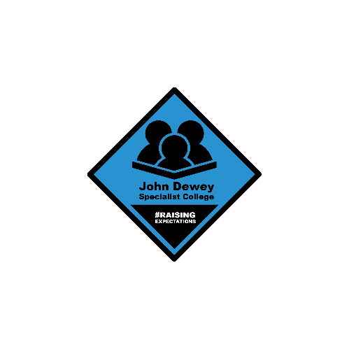
JOHN DEWEY SPECIALIST COLLEGE
COURSE APPLICATION FORM

Please complete the form and return by clicking Submit at the end, or by printing and posting your form to us at the address given.
Personal Details:
First Name: | Click or tap here to enter text. |  |  |  | Age: | Choose an item.
Last Name: | Click or tap here to enter text. |  |  |  | Date of Birth: | Click or tap here to enter text.
Address: | Click or tap here to enter text.
Click or tap here to enter text.
Click or tap here to enter text. |  |  |  |  | Postcode: | Click or tap here to enter text.
Home Tel: | Click or tap here to enter text. |  |  |  | Mobile Tel: | Click or tap here to enter text.
Emergency Contact Name: | Click or tap here to enter text. |  |  |  | Emergency Contact Tel: | Click or tap here to enter text.
Language(s) spoken: |  | Click or tap here to enter text.
Name of previous setting: |  |  | Click or tap here to enter text.
Social Worker’s Name: |  |  | Click or tap here to enter text.
Social Worker’s contact details: |  |  | Email:  Phone: | Click or tap here to enter text.  Click or tap here to enter text.
Qualifications achieved or working towards:
Please provide details of any qualifications that you have completed or are working towards, including the dates you completed them (if applicable).
Click or tap here to enter text.

Ethnic Background: Please tick the category you feel applies to you
☐ | White – Greek/Greek Cypriot | ☐ | Black or Black British Caribbean | ☐ | Asian or Asian British Any Other Asian background
☐ | White – Irish | ☐ | Black or Black British African | ☐ | Chinese
☐ | White - British | ☐ | Any Other Black background | ☐ | Prefer not to say
☐ | White Turkish/ Turkish Cypriot | ☐ | Asian or Asian British Indian
☐ | Any Other White background | ☐ | Asian or Asian British Pakistani
☐ | Any other ethnic background: Click or tap here to enter text.

Your support needs:
Please tell us as much as you can about the kind of support you need and when you need it to help us plan your time at college.
Do you need support with:
☐ | Moving around | ☐ |  | Personal Care |  | ☐ | Travelling
☐ | Eating & Drinking | ☐ |  | Behaviour towards others |  | ☐ | Self harm
☐ | PEG feeding | ☐ |  | Medication |  | ☐ | Communication
Do you use any of the following:
☐ | British Sign Language (BSL) | ☐ |  | Makaton Sign |  | ☐ | PECS
☐ | Objects of reference | ☐ |  | Braille |  | ☐ | Moon
☐ | Communication Aid (e.g. Eye Gaze, Grid talker) | ☐ |  | Another communication method not listed here
Physical Disability:
Please tick any that apply to you
☐ | A disability that affects your mobility. |  |  | ☐ | A disability that affects your hearing
☐ | A disability that affects your sight |  |  | ☐ | A long term health problem(s)
Briefly, tell us how your disability/ies affect you:
Click or tap here to enter text.

Medical Needs:
Please tell us about any medical conditions that you may need emergency treatment for:
☐ | Epilepsy (e.g. midazolam) |  |  | ☐ | Severe allergies (e.g. epipen)
☐ | Diabetes |  |  | ☐ | Asthma (e.g. inhalers)
☐ | Any other condition not listed |  |  |  | Click or tap here to enter text.
Before you start your course, you will be asked to complete a medical questionnaire in more detail. This information is kept confidentially and allows the college to plan support for you if you need help taking medication, require medication to be stored onsite and in case you require emergency treatment at any time.
Support to manage your behaviour / sensory needs:
Please help us make sure we can support you well by completing this section with as much information as possible.
☐ | Absconding / Running |  | ☐ |  | Manging emotional distress (e.g. depression/anxiety)
☐ | Repetitive behaviours (e.g. OCD, vocalisations) |  | ☐ |  | Physical aggression (intentional or unintentional (e.g. throwing, hitting)
☐ | Difficulties staying still for more than 10 minutes |  | ☐ |  | Sensitivity to noise, lights, touch.
☐ | Difficulties with busy places
☐ | Anything else not listed above |  |  |  | Click or tap here to enter text.

Supporting statement:
Tell us about yourself and why you want to continue studying
Things you like to do:
Favourite activities, lessons enjoyed at school, hobbies or interests, clubs etc
Click or tap here to enter text.

What are your plans for the future?
Click or tap here to enter text.

Things you really dislike or prefer not to do:
This will help us match you to a suitable group at college, or advise you further in your course choice.
Click or tap here to enter text.

Any other information relevant to your application:
Use this space to tell us more about any of the answers you have given already, or to provide other information you think we should know.
Click or tap here to enter text.

Statement of Confidentiality
This form is confidential to the student, referring agency and the College. The information is used to help the student and the college staff to plan an individual programme to meet the student’s needs and wishes, taking into account their strengths, interests and areas requiring development. It is also used to ensure the student’s safety and well being at College, enabling us to provide a high quality learning experience for the individual and to ensure that the student’s experience of further education is positive and successful.

Please note: If important information is not provided during the application process, this could result in the college being unable to meet student needs. Any serious incidents, which occur as a result, could affect the student’s place.

Please sign and date the form on completion as being fully accurate to the best of your knowledge and return to the Administrator at the address below.
Applicant signature:  (please leave blank if submitting online) | Click or tap here to enter text.
Referrer’s Name:  (please tell us this if someone else completed the form for you) | Click or tap here to enter text.
Date: | Click or tap to enter a date.

Please email your completed form to: admin@area51ed.org.uk

You can also print and post this form to us at:
The Admin Office
Area 51 Education Ltd
1, Mallard Place,
Coburg Road,
London
N22 6TS

